Optimization Management for Improving Water Quality in Beriwit River and Barito River Using Fuzzy Goal Programming Approach with Demerit Control

Prabowo Buddy Santoso   
Departement of Technology Management ITS Sepuluh November, Surabaya, East Java  
Email: 7032221013@student.its.ac.id

R Haryo Dwito Armono S.T., M.Eng., Ph.D  
Departement of Technology Management ITS Sepuluh November, Surabaya, East Java  
Email: armono@oe.its.ac.id

Raja Oloan Saut Gurning ST, M.Sc., Ph.D. CMarTech  
Departement of Technology Management ITS Sepuluh November, Surabaya, East Java  
Email: sautg@its.ac.id   
  
Marastika Wicaksono Aji Bawono S.Kom.,M.Kom.,M.M   
Departement of Technology Management ITS Sepuluh November, Telkom University, Surabaya, East JavaEmail: 7032221023@student.its.ac.id

ABSTRACT

The research proposes an "Optimization Management for Improving Water Quality in Beriwit and Barito River" using Fuzzy Goal Programming and demerit control to enhance waste management. It seeks stakeholder involvement for adaptive water quality improvement, emphasizing sustainability and community benefits. Fuzzy Goal Programming addresses uncertainty in aspiration levels, utilizing linear membership functions for fuzzy goals. Minmax Goal Programming, employing the D∞ metric, minimizes maximum deviations. Demerit Control Chart (DCC) integrates foundry processes, identifying defects, assigning weights, and establishing control limits for continuous improvement.Fuzzy Goal Programming enhances water quality at SP 05 and SP 09, optimizing BOD and DO parameters at inlet and outlet. Results demonstrate its effectiveness for informed water resource management, suggesting broader application for sustainable improvements in water quality.Fuzzy Goal Programming at SP improved water quality, optimizing BOD and DO. These successes highlight its effectiveness for informed water resource management. Recommendations include a monitoring system, integration into broader plans, and community engagement for sustained water quality.

Keyword: Water Quality Improvement, Fuzzy Goal Programming, Demerit Control

1. INTRODUCTION

. Rivers, as vital water sources, play a crucial role in meeting human and ecosystem needs. They serve as a primary provider of water for various daily activities such as fishing, agriculture, plantations, transportation, industry, and domestic needs. Changes in land use design, including the growth of agribusiness, cultivation areas, settlements, and modern infrastructure expansion, can significantly impact the hydrological conditions in a river basin (Permatasari et al.,

2017). The Barito River, located in South Kalimantan, faces significant pressure due to the discharge of waste from various community activities. The increase in population and economic activities within the Barito River Basin has contributed to the escalating waste disposal. Activities like coal loading and unloading and industrial processes involving cleaning agents contribute heavy metal waste. Additionally, water transportation can lead to oil spills, and sectors such as agriculture, livestock, and fisheries also contribute waste, especially heavy metals. Every human activity around the river contributes to water quality, and if waste accumulates on a large scale, it can disrupt the environmental balance and aquatic ecosystem (Alpiannur et al., 2022). To address these challenges, this research aims to formulate a solution through the "Optimization Management for Improving Water Quality in Beriwit River and Barito River Using Fuzzy Goal Programming Approach with Demerit Control." This approach combines Fuzzy Goal Programming with demerit control to achieve more efficient and focused waste management. Fuzzy Goal Programming handles the uncertainty in goals and constraints related to water quality, while demerit control sanctions excesses in certain limitations.

In this approach, optimization is directed towards more effective and efficient waste management. The Fuzzy Goal Programming model is designed to formulate fuzzy goals covering the desired water quality, while demerit control is applied to sanction conditions that violate specific limits. Demerit control creates incentives for stakeholders to comply with established water quality standards. Through this combination, it is expected to find a precise and effective solution to enhance water quality in Beriwit River and Barito River. The implementation of this approach is expected to bring positive changes in efforts to improve water quality in Beriwit River and Barito River. By considering fuzzy aspects, waste management can become more adaptive to variations in natural conditions and human activities. Meanwhile, demerit control provides a supervisory mechanism to ensure compliance with established water quality standards.

Sustainability is the key, and public awareness and active participation in maintaining river cleanliness are crucial factors. By understanding the impact of waste on environmental balance and aquatic ecosystems, it is hoped that the community can actively play a role in preserving and supporting the implementation of the proposed solutions. The success of this approach will bring long-term benefits to the environment and the well-being of the communities around Beriwit River and Barito River. The "Optimization Management for Improving Water Quality in Beriwit River and Barito River Using Fuzzy Goal Programming Approach with Demerit Control" approach attempts to present a comprehensive solution to the complex challenges related to waste management in these rivers. By combining the advantages of Fuzzy Goal Programming and demerit control, it is anticipated that an efficient, adaptive, and sustainable solution can be found. The implementation of this solution not only involves technical optimization aspects but also requires active support and participation from the community to ensure the sustainability of efforts to improve water quality in Beriwit River and Barito River.

**2. LITERATURE REVIEW**

## **2.1 Fuzzy Goal Programming (FGP)**

Conventional models of goal programming assume that decision makers can establish precise aspiration levels for each objective. However, in the majority of real-world situations, the exact levels of aspiration are uncertain. In such cases, the application of fuzzy goal programming becomes pertinent (Jana et al., 2022). The goal programming approach is designed to minimize deviations from the desired levels set by decision makers, employing various methods for this minimization process. There are three fundamental methods in goal programming, incorporating the consideration of priority and weight factors simultaneously. Following the introduction of Zadeh's "Fuzzy Sets" theory, Bellman and Zedeh proposed the concept of Decision Making in a Fuzzy Environment (Chen & Xu, 2012). This advancement significantly contributed to various approaches within goal programming methods, aligning with the advancements observed in linear programming. In Fuzzy Goal Programming, the goals happen to be fuzzy in the three types of fuzziness (Alfiani et al., 2022). The coefficients in all these goals are crisp, but only the goals themselves are fuzzy (Kalaiarasi et al., 2022). The following formula are:

|  |  |
| --- | --- |
| $$fuzzy goal A: {\left(AX\right)}_{i} \tilde{≤} b_{i}$$ | (1) |
| $$fuzzy goal B: {\left(AX\right)}_{i} \tilde{≥} b_{i}$$ | (2) |
| $$fuzzy goal C: {\left(AX\right)}_{i} \tilde{=} b_{i}$$ | (3) |

Fuzzy goals can be characterized by employing various types of membership functions. The linear membership functions corresponding to the aforementioned fuzzy goals are illustrated below.



**FIGURE 1.**Plot Membership Function Fuzzy Goal A

Figure 1 displays the membership function and its corresponding graph for Fuzzy Goal A. The structure in Figure 1 descends based on the $Δ_{İR}$ value.

|  |  |
| --- | --- |
| $$μ_{i}\left(AX\right)=\left\{\begin{aligned} 1, {\left(AX\right)}_{i}≤b_{i} \\ \frac{{(b}_{i}+∆_{iR})-{\left(AX\right)}_{i}}{∆_{iR}},b_{i}≤{\left(AX\right)}_{i}≤b_{i}+∆_{iR} \\ 0 ,{\left(AX\right)}_{i} ≥ b_{i} + Δ_{İR}\end{aligned}\right.$$ | (4) |



**FIGURE 2.**Plot Membership Function Fuzzy Goal B

|  |  |
| --- | --- |
| $$μ_{i}\left(AX\right)=\left\{\begin{aligned} 1, {\left(AX\right)}_{i}≥b_{i} \\ {\left(AX\right)}_{i}-\left(b_{i}-Δ_{İL}\right), b_{i}-Δ_{İL}≤{\left(AX\right)}_{i}≤b_{i} \\ 0, {\left(AX\right)}_{i}≤b_{i}-Δ_{İL}\end{aligned}\right.$$ | (5) |

The degree of membership in Fig. 1 increases as the $Δ_{İL}$ value varies. Fig. 2 illustrates the membership function and its corresponding graph for Fuzzy Goal B.

|  |  |
| --- | --- |
| $$μ_{i}\left(AX\right)=\left\{\begin{aligned} 0, {\left(AX\right)}_{i}≤b_{i}-Δ_{İL} or {\left(AX\right)}_{i} ≥ b_{i} + Δ_{İR} \\ \frac{{\left(AX\right)}_{i}-\left(b_{i}-Δ_{İL}\right)}{Δ_{İL}}, b_{i}-Δ_{İL}≤{\left(AX\right)}_{i}≤b_{i} \\ \frac{{(b}_{i}+∆_{iR})-{\left(AX\right)}_{i}}{∆_{iR}}, b_{i}{≤\left(AX\right)}_{i}≤b_{i}+∆_{iR}\end{aligned}\right.$$ | (6) |



**FIGURE 3.**Plot Membership Function Fuzzy Goal C

In Fig. 3, the membership function and its graph for Fuzzy Goal C are presented. Within this figure, the membership degree ascends with variations in $Δ_{İL}$ value and exhibits a descending structure corresponding to $Δ_{İR}$ value.

## **2.2 Min-Max Goal Programming**

Referred to as Chebyshev Goal Programming, Minmax Goal Programming employs the $D_{∞}$ metric in lieu of the $D_{1}$ metric utilized in Prioritized and Weighted Goal Programming methods. The mathematical definition of Minmax Goal Programming is as follows (Wang et al., 2021).

|  |  |
| --- | --- |
| $$\min{d}$$ Subject to: $$α_{i}\frac{n_{i}}{k_{i}}+β_{i}\frac{p_{i}}{k_{i}}≤d$$ $$f_{i}\left(x\right)+n_{i}-p_{i}=b_{i}$$ $n_{i}.p_{i}=0,d,n_{i},p_{i}≥0$ and $i=1,…,K.$ | (7) |

In this context, 𝑏𝑖 represents the aspiration level for the $i$ goal, while $n_{i}$ and $p_{i}$ denote the negative and positive deviations from the aspiration value of the $i$ goal. Additionally, $k_{i}$ serves as the normalization constant specific to the ith goal.

In Minmax Goal Programming of this kind, the objective is to minimize the maximum deviation instead of minimizing the sum of deviating variables, a departure from the weighted and prioritized frameworks (Hasbiyati et al., 2023). Goals are individually defined, and the solution is obtained using the traditional simplex algorithm in this model. The model's objective function comprises the distance parameter, determining the minimization of the maximum deviation with formula (Mesquita-Cunha et al., 2023):

|  |  |
| --- | --- |
| $$Max λ$$ Subject to: $${\left(AX\right)}_{i}-p_{i}≤b_{i}$$ $$λ+\frac{1}{∆_{iR}}p_{i}≤1$$ $${\left(AX\right)}_{i}+n_{i}≥b_{i}$$ $$λ+\frac{1}{∆_{iL}}n≤1$$ $${\left(AX\right)}_{i}+n_{i}-p_{i}=b_{i}$$ $$λ+\frac{1}{∆_{iL}}n_{i}+\frac{1}{∆_{iR}}p_{i}≤1$$ $$λ,p_{i},n_{i}≥0$$ $$X∈C_{s}$$ | (8) |

In this context, $n_{i}$ and $p_{i}$ represent the deviated variables for the $i$ goal, while $Δ_{iL}$ and $Δ_{iR}$ denote the acceptable deviations on the left and right sides for the ith fuzzy goal. Additionally, $b_{i}$ corresponds to the desired level for the $i$ goal.

## **2.3 Demerit Control Chart (DCC)**

Taking into account the directives outlined in the preceding chapter, the implementation methodology of the DCC into foundry processes is demonstrated using ductile cast iron castings as an example (Pan et al., 2018). This approach is versatile and can be adapted for application in other processes with similar characteristics. Further details regarding these steps are expounded upon in subsequent sections of the paper.

1. Examining the process under analysis and identifying potential defects involve studying the historical record of issues associated with the specific process or similar processes (in the case of novel processes). This investigation aims to establish the types of defects that could manifest in the given process.

2. Identifying the criticality classes of defects and assigning corresponding weights is carried out based on the specific characteristics of the casting process.

3. Gathering a pilot trial from a process under the most advantageous conditions is undertaken to create a "master pattern" that serves as a reference for evaluating the outcomes of the ongoing process control.

4. Establishing the mean number of Demerits per unit and its corresponding standard deviation involves calculating the average Demerit per unit using the following formula:

|  |  |
| --- | --- |
| $$\overline{u}=w_{c1}{\overline{u}}_{c1}+w_{c2}{\overline{u}}_{c2}+…+w_{cn}{\overline{u}}_{cn}$$ | (9) |

As an illustration, the following formulas should be applied for the C1 category.

|  |  |
| --- | --- |
| $$u_{j,c1}=\frac{\sum_{i=1}^{n_{j}}{x_{i,c_{1}}}}{n_{j}}$$ | (10) |
| $${\overline{u}}_{c1}=\frac{\sum_{j=1}^{k}{U_{j,c_{1}}}}{k}$$ | (11) |

The standard deviation associated with the mean Demerit number per unit is computed utilizing the subsequent formula:

|  |  |
| --- | --- |
|  | (12) |

5. Establishing control limits within a DCC and plotting points from the pilot trial involve calculating the control limits using the following formulas.

|  |  |
| --- | --- |
|  | (13) |

3. RESULT AND ANALYSIS

## **3.1 Calculate Demerit Control Chart**

In conducting quality control and evaluating specific data parameters, the calculation of the Demerit Control Chart becomes a crucial step. By using demerit points, we can measure how far a parameter value is from the established upper and lower control limits. This allows the identification and monitoring of the level of variability and potential quality issues. Let's explore the process of calculating the Demerit Control Chart to analyze and understand the behavioral patterns of the tested data parameters. Additionally, the demerit diagram is utilized to assess the optimal level that can be controlled based on pollution indicators at two locations, namely SP 05 and SP 09, with Dissolved Oxygen (DO) and Biological Oxygen Demand (BOD) indicators. Observations are conducted at the inlet and outlet, represented as follows:

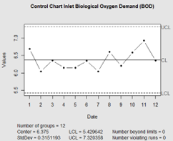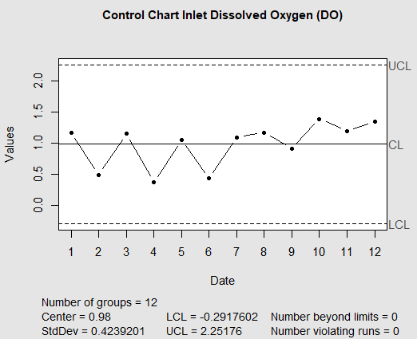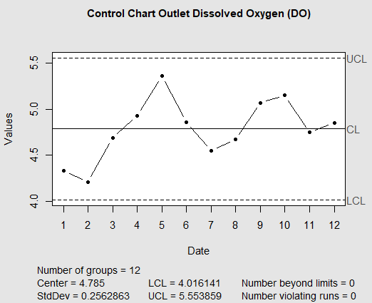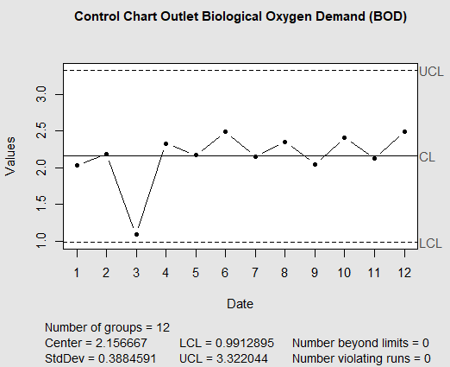

**FIGURE 4.**Plot DCC Sp 05 For Indicator DO and BOD

The detailed scrutiny of Figure 4 unveils crucial insights into the control dynamics of key water quality parameters at the HJ 05 pH point. Significantly, the Demerit control values for Inlet Dissolved Oxygen (IDO), Inlet Biological Oxygen Demand (IBOD), Outlet Dissolved Oxygen (ODO), and Outlet Biological Oxygen Demand (OBOD) emerge as focal points, narrating a compelling story of controlled values and stable performance. IDO, a pivotal indicator of water quality reflecting oxygen concentration for aquatic organisms, exhibits a controlled pattern at HJ 05. The Demerit control value for IDO signifies control, drawn from the consistent oscillation within a well-defined range centered around the centroid—the mean or central value serving as a benchmark for assessing control stability. Similarly, IBOD, measuring the oxygen required by microorganisms for decomposing organic matter, mirrors the controlled nature observed in IDO. At HJ 05, IBOD values remain within the centroid confines, avoiding excursions beyond the lower and upper control limits (LCL and UCL), indicating stable and regulated biological oxygen demand essential for a healthy aquatic ecosystem. Shifting attention to ODO, pivotal for gauging oxygen levels in effluent water, its controlled behavior at HJ 05 manifests through consistent fluctuations within acceptable limits. Values neither dip below LCL nor soar beyond UCL, showcasing the effectiveness of the control mechanisms in place. Complementing ODO, OBOD contributes to the narrative of controlled water quality parameters at HJ 05 by measuring the oxygen demand exerted by microorganisms in effluent. The Demerit control value ensures alignment with the centroid, reflecting a systematic and well-maintained oxygen demand level in outlet water. The consistent adherence to the centroid and avoidance of breaching LCL and UCL values collectively depict a tightly controlled water quality management system at the HJ 05 pH point, crucial for preserving the ecological balance of aquatic systems impacted by effluent discharge.

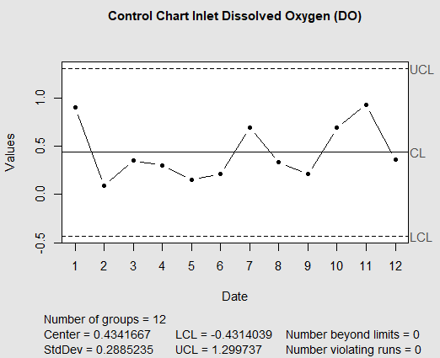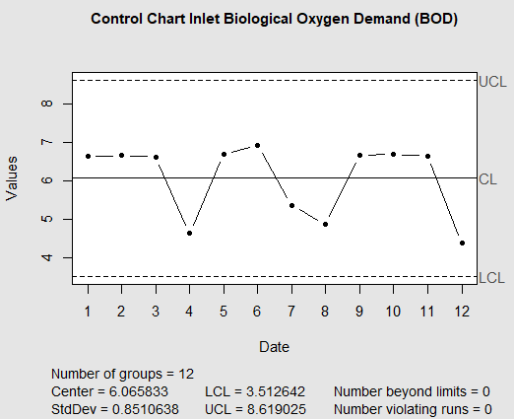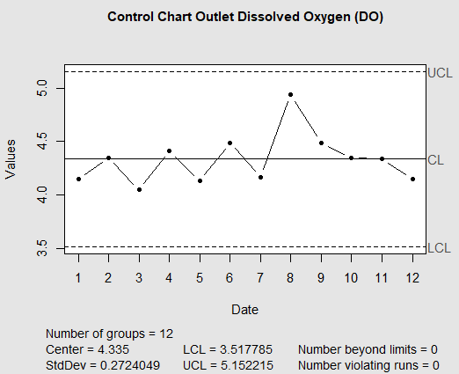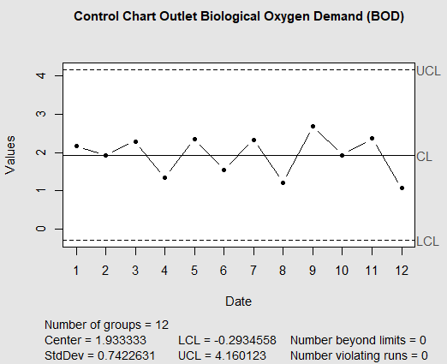

**FIGURE 5.**Plot DCC Sp 09 For Indicator DO and BOD

A detailed examination of Figure 5 sheds light on the control dynamics of key water quality parameters at the spHJ 09 point. Notably, the focal points in this analysis are the Demerit control values associated with Inlet Dissolved Oxygen (IDO), Inlet Biological Oxygen Demand (IBOD), Outlet Dissolved Oxygen (ODO), and Outlet Biological Oxygen Demand (OBOD), presenting a compelling narrative of controlled values and stable performance. IDO, a pivotal indicator reflecting oxygen concentration for aquatic organisms, demonstrates a controlled pattern at spHJ 09. The Demerit control value for IDO underscores this control, as evidenced by consistent oscillations within a defined range centered around the centroid—an indicative benchmark for assessing control stability. Similarly, the controlled nature observed in IDO is mirrored in IBOD, which measures the oxygen required by microorganisms for decomposing organic matter. At spHJ 09, IBOD values remain within the centroid limits, avoiding excursions beyond the prescribed lower and upper control limits (LCL and UCL), indicative of a stable and regulated biological oxygen demand crucial for a healthy aquatic ecosystem. Transitioning to ODO, essential for gauging oxygen levels in effluent water, its controlled behavior at spHJ 09 is evident through consistent fluctuations within acceptable limits. Values neither drop below the LCL nor exceed the UCL, highlighting the effectiveness of the implemented control mechanisms. In tandem with ODO, OBOD contributes to the narrative of controlled water quality parameters at spHJ 09 by measuring the oxygen demand exerted by microorganisms in effluent. The Demerit control value ensures alignment with the centroid, reflecting a systematic and well-maintained oxygen demand level in outlet water. The sustained adherence to the centroid and the avoidance of breaching LCL and UCL values collectively portray a tightly controlled water quality management system at the spHJ 09 point, playing a crucial role in preserving the ecological balance of aquatic systems affected by effluent discharge.

## **3.2 Calculate Membership Function**

The calculation of fuzzy membership degrees for the values of DO (Dissolved Oxygen) and BOD (Biochemical Oxygen Demand) for locations SP 05 and SP 09 is categorized through the process of fuzzyfication, namely "Low," "Medium," and "High," each of which is calculated using equations (4), (5), and (6). In the case of SP 05, The visualization of membership degrees for each variable DO and BOD in SP 05 is illustrated as follows:

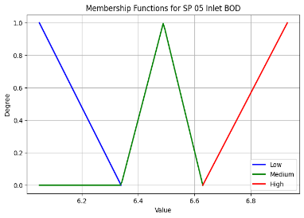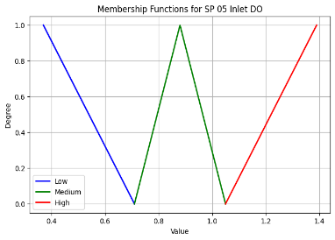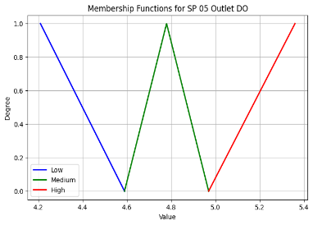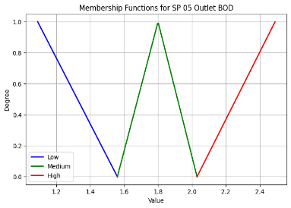

**FIGURE 6.**Plot Membership Function Sp 05 For Indicator DO and BOD

In Figure 6, the membership functions for the "SP 05 Outlet BOD" category represent three levels: "Low," "Medium," and "High." Each level is assigned a different color for ease of understanding. The "Low" membership function (blue) indicates a maximum membership degree of 1.0 for BOD values ≤ 1.09, with a linear decrease towards 0.0 as BOD increases up to 1.56. The "Medium" membership function (green) reaches its peak in the range of 1.56–1.80, where the membership degree increases from 0.0 to 1.0 and then decreases to 0.0 in the interval 1.80–2.03. The "High" membership function (red) attains a maximum value of 1.0 for BOD values ≥ 2.49, with a linear increase from 0.0 to 1.0 in the range of 2.03–2.49. This conclusion provides a visual representation of how BOD values are categorized as "Low," "Medium," or "High" based on the associated fuzzy membership degrees.

Subsequently, calculations were carried out for location SP 09 using the same approach as based on SP 05 for the fuzzy membership degrees in the process of fuzzyfication. The computation involves determining the fuzzy membership degrees for both Dissolved Oxygen (DO) and Biochemical Oxygen Demand (BOD) categories. This process ensures consistency in evaluating the membership strength of data points in relation to "Low," "Medium," and "High" levels for both locations, thereby facilitating a comprehensive analysis of water quality. The method employed in SP 05 is replicated in SP 09, ensuring a parallel assessment of fuzzy membership degrees for a thorough examination of the two locations' environmental characteristics. The visualization of membership degrees for each variable DO and BOD in SP 09 is 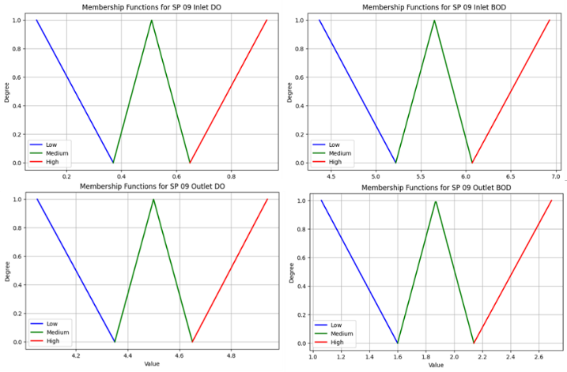illustrated as follows:

**FIGURE 6.**Plot Membership Function Sp 09 For Indicator DO and BOD

In Figure 7, illustrating the membership functions for the "SP 09 Outlet BOD" category, the distinct colors and membership degrees provide valuable insights into water quality characterization. The "Low" membership function, denoted by the blue color, attains a maximum degree of 1.0 for BOD values ≤ 1.06, gradually declining to 0.0 as BOD increases up to 1.60. The "Medium" function, represented in green, peaks between 1.60 and 1.87, reaching a maximum degree of 1.0. Notably, there is a linear increase from 0.0 to 1.0 followed by a decrease to 0.0 within the range of 1.87 to 2.14. The "High" function, marked in red, achieves a maximum degree of 1.0 for BOD values ≥ 2.69, displaying a linear increase from 0.0 to 1.0 in the range of 2.14–2.69. This visual analysis provides a comprehensive understanding of the "Low," "Medium," and "High" categories based on fuzzy membership degrees and their variations with changing BOD values at the SP 09 location.

## **3.3 Calculate Optimal DO and BOD**

The use of Fuzzy Goal Programming is employed to optimize the threshold values that need to be maintained for the water quality of the Barito River. In this context, water quality indicators involve the levels of Dissolved Oxygen (DO) and Biochemical Oxygen Demand (BOD), and the optimization is carried out by applying equations (7) and (8). The Fuzzy Goal Programming approach enables the adjustment of water quality threshold values that are more adaptive and responsive to natural condition fluctuations. Using this method, the primary objective is to achieve a balance between the needs of river ecosystem conservation and the sustainability of water resources, while also considering possible variability in DO and BOD water quality parameters. The results of the calculations for each location, SP 05 and SP 09, are presented as follows.:

|  |  |  |
| --- | --- | --- |
| **Inlet Parameter** | **Average of Aktual Value** | **Average of Optim Value** |
| Biological Oxygen Demand (BOD) | 6.38 | 3.67 |
| Dissolved Oxygen (DO) | 0.98 | 0.58 |
| **Outlet**  **Parameter** | **Average of Aktual Value** | **Average of Optim Value** |
| Biological Oxygen Demand (BOD) | 2.16 | 1.32 |
| Dissolved Oxygen (DO) | 4.79 | 2.78 |

**TABLE 1.**Result Fuzzy Goal Programming SP 05 For Indicator DO and BOD

From Table 1 show outcomes of Fuzzy Goal Programming for water quality indicators at SP 05, as presented in Table 1, reveal noteworthy improvements in the biological and dissolved oxygen parameters at both the inlet and outlet locations. In terms of Biological Oxygen Demand (BOD), the average actual values of 6.38 and 2.16 have been significantly optimized to 3.67 and 1.32, respectively, at the inlet and outlet. This signifies a substantial enhancement in water quality, emphasizing the effectiveness of the optimization process. Similarly, for Dissolved Oxygen (DO), the optimization has led to a reduction in average values from 0.98 to 0.58 at the inlet and from 4.79 to 2.78 at the outlet. These results underscore the successful application of Fuzzy Goal Programming in achieving improved water quality at SP 05, reflecting its potential for informed water resource management.

|  |  |  |
| --- | --- | --- |
| **Inlet Parameter** | **Average of Aktual Value** | **Average of Optim Value** |
| Biological Oxygen Demand (BOD) | 6.07 | 3.49 |
| Dissolved Oxygen (DO) | 0.43 | 0.24 |
| **Outlet**  **Parameter** | **Average of Aktual Value** | **Average of Optim Value** |
| Biological Oxygen Demand (BOD) | 1.93 | 1.12 |
| Dissolved Oxygen (DO) | 4.34 | 2.54 |

**TABLE 2.**Result Fuzzy Goal Programming SP 09 For Indicator DO and BOD

From Table 2 presented in the table for water quality at SP 09 illustrates a substantial enhancement achieved through Fuzzy Goal Programming optimization. At the inlet, the average Biological Oxygen Demand (BOD) value has notably decreased from 6.07 to 3.49, indicative of a significant improvement in water quality concerning this parameter. Simultaneously, the average Dissolved Oxygen (DO) level at the inlet has increased as a result of optimization, reducing from 0.43 to 0.24, reflecting improved oxygenation in the water. At the outlet, the Fuzzy Goal Programming approach has similarly led to positive outcomes, optimizing the average BOD from 1.93 to 1.12, and the average DO from 4.34 to 2.54. These improvements underscore the efficacy of Fuzzy Goal Programming in enhancing water quality at SP 09, emphasizing its potential for informed and effective water resource management.

## **3.4 Policy of Reccomendation**

The outcomes of Fuzzy Goal Programming for water quality indicators at SP 05 and SP 09 in the Barito River underscore a significant improvement in water quality, specifically in Biological Oxygen Demand (BOD) and Dissolved Oxygen (DO) parameters at both the inlet and outlet locations. These results offer valuable insights into effective water quality management strategies. In light of these achievements, it is recommended to establish a robust monitoring system based on Fuzzy Goal Programming outcomes for continuous assessment of BOD and DO levels at both SP 05 and SP 09. This will enable immediate responses to deviations, ensuring swift intervention to maintain water quality. Furthermore, the successful application of Fuzzy Goal Programming should be integrated into broader water quality management plans to enhance overall effectiveness. Community engagement, periodic reassessment, and collaboration with stakeholders are crucial components of a comprehensive strategy to sustain and further improve the water quality of the Barito River.

4. CONCLUSSION

The implementation of Fuzzy Goal Programming at SP has yielded noteworthy advancements in water quality, specifically targeting improvements in Biological Oxygen Demand (BOD) and Dissolved Oxygen (DO) parameters. The optimization process successfully reduced BOD and enhanced DO, showcasing the effectiveness of Fuzzy Goal Programming for informed water resource management. Positive outcomes were similarly observed at SP, demonstrating the efficacy of Fuzzy Goal Programming in contributing to a substantial enhancement in water quality. The improvements in BOD and DO parameters underscore the potential of this programming approach for informed and effective water resource management.

The positive outcomes at SP underscore the necessity for strategic policy recommendations. Recommendations include the establishment of a robust monitoring system based on Fuzzy Goal Programming outcomes for continuous assessment of BOD and DO levels. Additionally, there is a call for the integration of successful Fuzzy Goal Programming applications into broader water quality management plans. Recommendations also emphasize fostering community engagement, periodic reassessment, and collaboration with stakeholders as crucial components for sustaining and further improving water quality. These proposed policies aim to leverage the demonstrated successes of Fuzzy Goal Programming, creating a comprehensive framework for effective water quality management.

5. SUGGESTION

Future research in water quality management can build upon the success of Fuzzy Goal Programming demonstrated in optimizing water quality at SP. A promising avenue is the development of advanced Fuzzy Goal Programming models that consider additional parameters and intricate relationships for a more comprehensive optimization of water quality indicators. Integrating machine learning techniques, such as artificial neural networks or genetic algorithms, with Fuzzy Goal Programming could enhance the accuracy and efficiency of optimization processes. Addressing temporal variations in water quality by developing dynamic models adaptable to changing environmental conditions is crucial.

Multi-objective optimization can be explored to simultaneously consider various water quality parameters, providing a holistic understanding of trade-offs and synergies. Evaluating the applicability of Fuzzy Goal Programming in different geographic contexts and diverse river basins will contribute to its generalizability. Integrating community participation and stakeholder engagement methodologies can enhance the social sustainability of water resource management. Real-time monitoring systems based on Fuzzy Goal Programming outcomes can enable adaptive management strategies. Conducting economic and environmental impact assessments will evaluate the cost-effectiveness and ecological consequences of Fuzzy Goal Programming-based water quality management. Interdisciplinary collaborations and extensive case-specific applications will ensure the practicality and reliability of Fuzzy Goal Programming models in real-world scenarios, advancing our understanding of water quality management and contributing to sustainable water resource management frameworks.

# 6. **References**

Alfiani, C., Zavina, M., Khasanah, U., Fadli, M. N., & Indahsari, A. (2022). Penerapan Fuzzy Goal Programming dalam Penerapan Fuzzy Goal Programming dalam Pengoptimalan Perencanaan Produksi. *Lebesgue: Jurnal Ilmiah Pendidikan Matematika, Matematika dan Statistika Vol. 3, No. 2*.

Alpiannur, Rahman, A., & Rahman, M. (2022). Daya Tampung Beban Pencemar di Daerah Aliran Sungai Barito (Sub Daerah Aliran Sungai Nagara, Sub Daerah Aliran Sungai Marabahan dan Sub Daerah Aliran Sungai Kuin) Provinsi Kalimantan Selatan. *Aquatic, Vol.5, No.1*, 1-19.

Chen, A., & Xu, X. (2012). Goal programming approach to solving network design problem with multiple objectives and demand uncertainty. *Expert Syst. Appl. 39*, 4160-4170.

Hasbiyati, I., Desri, R., & Gamal, M. H. (2023). Pre-Emptive Goal Programming Method For Optimizing Production Planning. *Barekeng: Journal of Mathematics and Its Applications Volume 17 Issue 1*, 65-74.

Jana, R., Sharma, D., & Mehta, P. (2022). A probabilistic fuzzy goal programming model for managing the supply of emergency relief materials. *Ann Oper Res 319 (1)*, 149-172.

Kalaiarasi, K., Henrietta, H., Sumathi, M., & Raj, A. (2022). Economic Order Quantity in a Fuzzy Environment for a Periodic Inventory Model with Variable Demand. *Iraqi Journal for Computer Science and Mathematics*.

Mesquita-Cunha, M., Figueira, J. R., & Barbosa-Póvoa, A. P. (2023). New ϵ−constraint methods for multi-objective integer linear programming: A Pareto front representation approach. *European Journal of Operational Research, Volume 306, Issue 1*, 286-307.

Permatasari, R., Arwin, & Natakusumah, D. K. (2017). Pengaruh Perubahan Penggunaan Lahan terhadap Rezim Hidrologi DAS (Studi Kasus : DAS Komering). *Jurnal Teoretis dan Terapan Bidang Rekayasa Sipil Vol. 24, No.1*.

Wang, C.-N., Nhieu, N.-L., & Tran, T. T. (2021). Stochastic Chebyshev Goal Programming Mixed Integer Linear Model for Sustainable Global Production Planning. *Mathematics, 9, 483.*